|  |  |
| --- | --- |
| Ex no.02  Date: | Install a C compiler in the virtual machine croated using virtual box and execute simple programs |

**AIM:**

Install a C compiler in the Virtual machine using virtual box and execute simple program.

**PROCEDURE:**

1. Install GCC compiler using the following commands

a. sudo apt update

b. sudo apt-get install gcc

c. gcc –version (To check the installation of GCC)

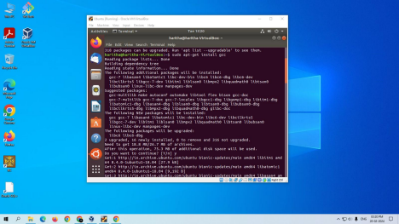

**SIMPLE C PROGRAM:**

P1.c:

#include<stdio.h>

int main(){

printf(“Hello”);

}

1. Type a Hello world C program in a text editor.

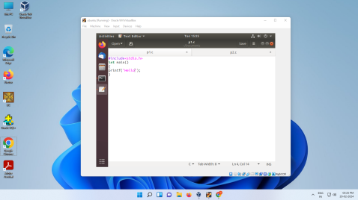

1. Save in the appropriate location with an extension of .c

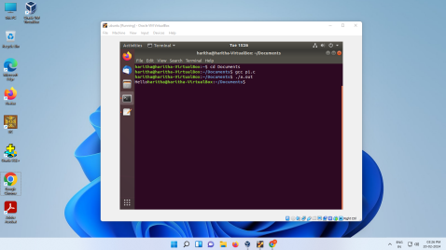

|  |  |  |
| --- | --- | --- |
| **Mark**  **split up** | **Max**  **Mark** | **Marks**  **Awarded** |
| **CEO** | 25 |  |
| **OUTPUT** | 25 |  |
| **VIVA** | 10 |  |
| **TOTAL** | 60 |  |

**RESULT:**

Thus, the program is executed successfully.